DM2199 COMPUTER GRAPHICS PROJECT

Academic Year 2016/2017 Semester 2

**Final Report**

**Team Number / Name 02 - Team**

**Project Title: Into the carnival**

**Members 162548Y Lucas Nguyen Thai Vinh (Leader)**

**161953P Shishanth Kaliannan**

**162514Z Lim Ziyi Jean**

**151593S Gabriel D’Cotta**

# Game idea/concept (description):

The concept is an action based game, whereby carnivals are now held on planets. Player will be able to explore the carnival and play with mini games. Player can play games like shooting enemies and treasure hunting, driving a car, jumping on platforms, and flying a spaceship whilst shooting other spaceships. Mini games are created by highly advanced technology of virtual reality, that is capable of producing hyper realistic environments. There will also be a carousel for the player to interact with. A starting sum of money(called star rocks) will be given to the player to enter minigames and play with the carousel. More money can be earned by playing mini-games. The objective of the game is to let the player explore our own interpretation of a futuristic carnival.

# Project schedule and timeline of task breakdown:

There was minor work done on the first day as it was mainly for our proposal but we started on mouse input, boundary checking, character movement and NPC modeling and designing.

After planning out what we had to do, and what we wanted to do, we continued and completed our mouse input and boundary checking which we did for the first 3 days.

# 

# 

# 

# 

# 

# 

# 

# 

# Description of features (> 50 words for each feature):

**Shooting & treasure hunting:**

Player, with 3 health, will be placed in a dark room with a gun that shoots laser beam, and a torchlight. The player will also have the option of undergoing tutorial. Due to the dark room, the player will only be provided with a limited vision. A treasure will be placed randomly, containing either health or money. However, there will be enemies trying to attack the player and the player will be notified; which explains the gun: it is to shoot the enemies with laser beams so that the enemies will disappear. The goal of this game is to find treasures and collect as many rewards as possible, without coming into contact with enemies.

**Driving:**

Player will be transported into a car, and player can control the car from a third-person’s view. The player will have a visual of both health and fuel for the car. Multiple obstacles(rocks),enemies, healths, and fuel will be placed throughout the scene. Obstacles will prevent the car from moving. Enemies will explode and decrease the health of the car when near. Health and money can be gained throughout the map. The car’s fuel will be decreased when it is in motion, however, it can be gained by fuels placed throughout the map.

**Jumping:**

Inspired by super mario, player will be playing a jumping on platform from a first-person viewpoint. When player enters the game, the player will be spawned onto a starting platform in a white lab with a lot of randomly generated and colourful multi-dimensional floating platforms. The player will be starting at the front of the lab, at one platform. The goal of the game is to get all the treasure before going to the ending platform which is at the end of the lab, without falling. If the player falls, the player will lose the game and has to start again.

**Spaceship:**

In hopes of creating a mini-game with a different mechanic from the other mini-games, this mini-game, which is inspired by an older 2D top-down view game (can’t remember the name of the original), has a different camera movement. Similar to the game, you would shoot the enemy UFOs that spawn, except that the UFOs spawn from the center and move to the ends. If it crosses a border, you'll lose the game and be brought back to the main scene where you can try again.

# Knowledge applied:

**Coding:** Singleton pattern, Physics , Vector, STL container(Iterator), Multidimensional array, Classes, Data Abstraction, Pointers, Map, Enumerations

**Art:** Maya and photoshop

**Management**: Agile Management, Scrum meetings, DOCUMENTATION???

# 

# Problems encountered/ problems solved / Lessons learnt:

1. **Encountered:** Shishanth had 3 “for” loops for enemy spawning. So, a 100 x 500 x 500 loop. It was too much.

**Solved:** Jean couldn’t stand it and added in a random number generator function,

and reduced the number of “for” loops to one.

**Learnt:** Let your friends look at your code. They can help optimise your code.

**2.**  **Encountered:** There was an issue with the light on the ground. In shooting, it always seems as if there are two lights even if there is just one. Not only that, a light will always be showing even when the only light is set to power 0. Also, when there is a fixed light, it will always show only half of the light. And when moved nearer, the light seems to move away from the player, but in the shape of a circle.

**Solved:** The problem laid in the normal of the quads. The quad for ground mesh was drawn in the x-y axis. However, the normal was in the y-coordinate, when it should have been in the z-coordinate. Hence, resulting in the odd behaviour of the light.

**Learnt:** The most simple answer may often be overlooked in the most unexpected and small area. We learn that we must always pay attention to even the smallest detail, and to backtrack as far as we can, to make sure that everything is correct from the foundation.

**3.**   **Encountered:** Tasks/bug-fixing seems to take much longer than usual.

**Learnt:**  If one team mate cannot solve a bug, verbalise it to another team member. It is the alternate form of rubber duck debugging. Not only does it help team mates to better understand each other’s code, but it also allows the coder to confirm that he/she has the full understanding of his/her own code. Also, team members can help to solve each other’s bugs!

**4.**   **Encountered:** Shishanth’s codes keeps getting deleted/unsaved (poor shish).  Unfortunately, it seems like it has been a frequent occurrence. Shishanth has multiple copies. Also, poor Shishanth keeps working on multiple files(because of code reference and copies) at the same time because he wants to have no merging conflicts, which he does not have. :D However, forgetful Shishanth keeps forgetting to save the current codes that he is working on. Hence, the decrease of productivity because he has to redo the codes.

**Learnt:** Learnt that only work on one file, and keep a copy! To solve merging conflicts, just notify everyone of which files they will be touching. If both team members are editing the same file, one of them may keep a copy of the changed file, reverse commt, pull from source tree, and put the additional codes in.

# Future enhancements/improvements:

## Can add in NPCs ,that walks around randomly, to populate the scene.

## Can add more interactive objects for the player to interact with, like cotton candy machines and fortune teller.

# 

# 

# 

# 

# 

# 

# Screenshots:

Menu Screen with mouse-over

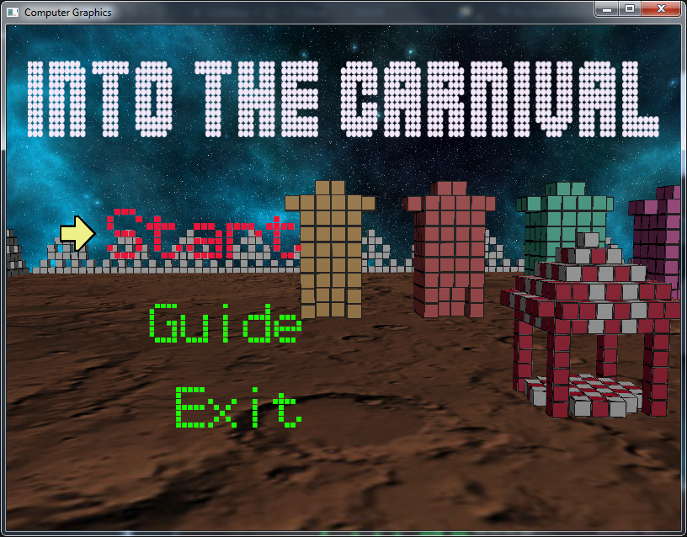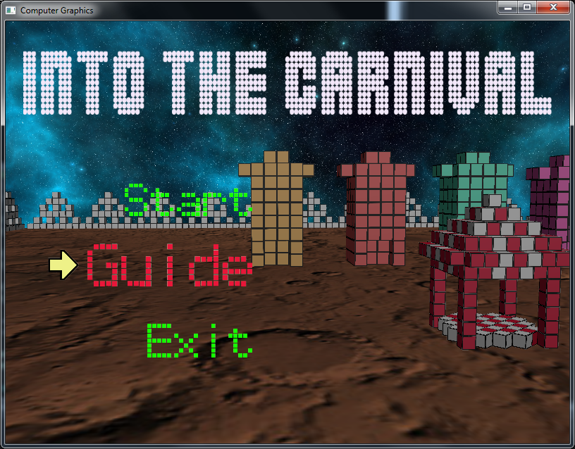Working Money system

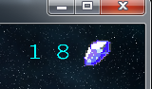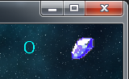

Main Carnival Scene

Main Scene A Carousel

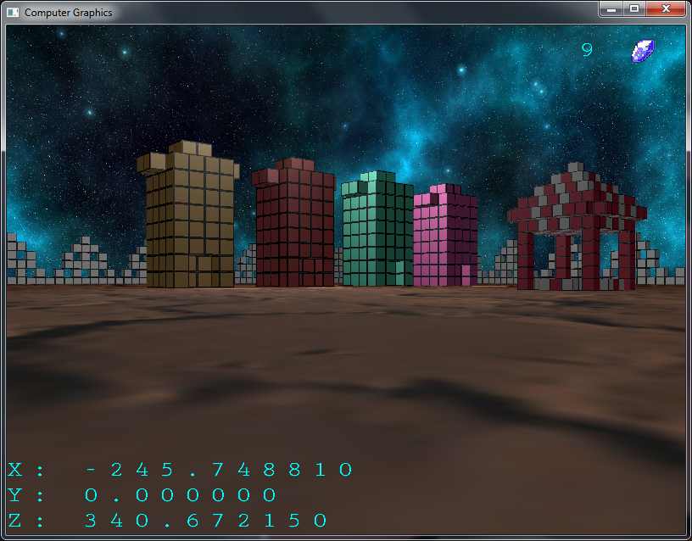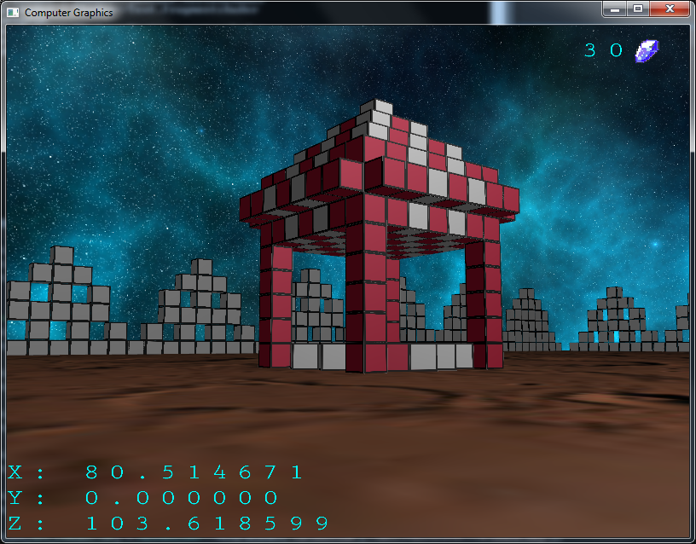

Our Boarders Building design and shape

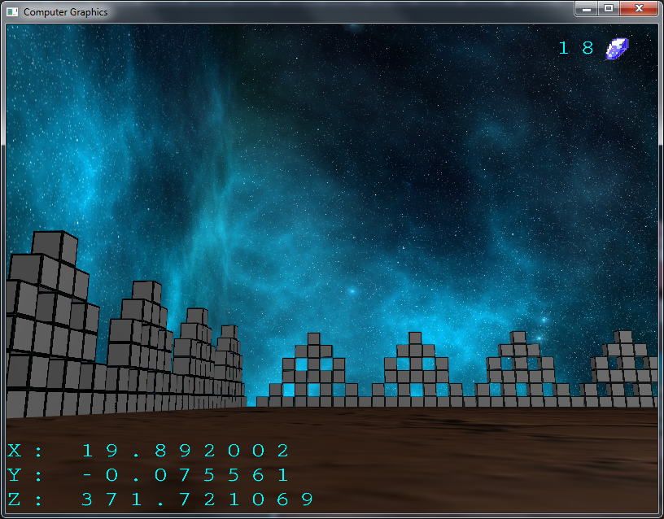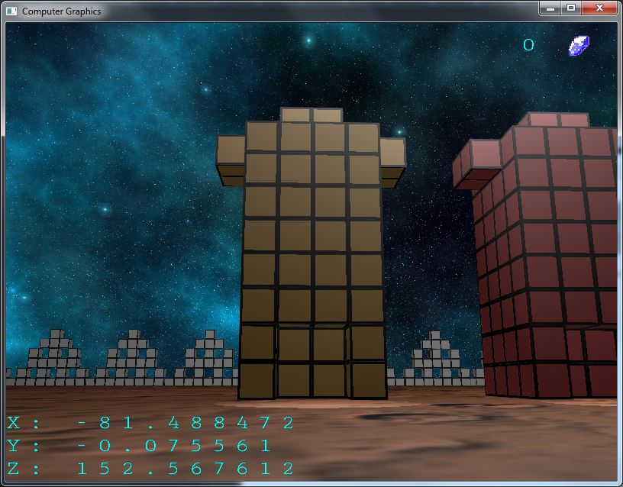

Riding on the Carousel (Can’t really see much here)

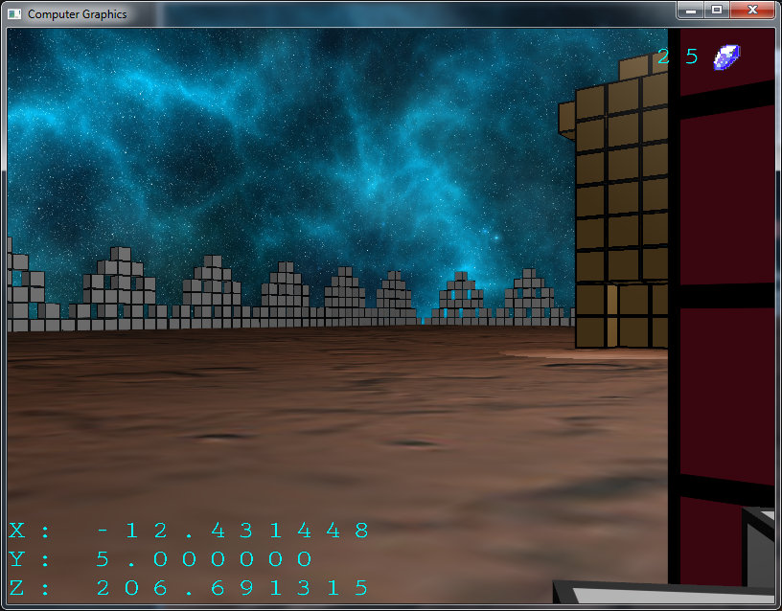

Jumping Game

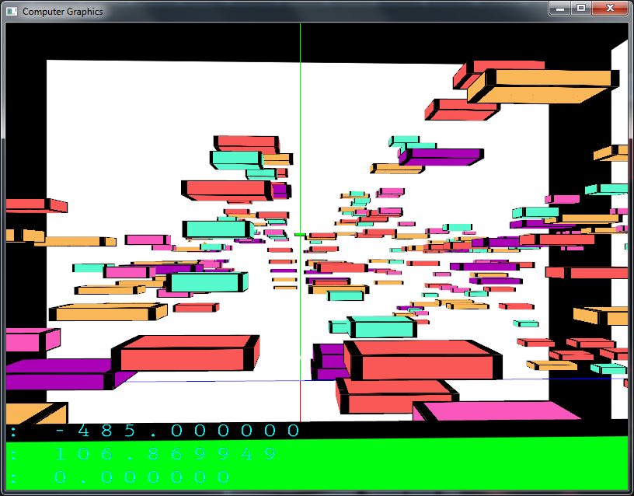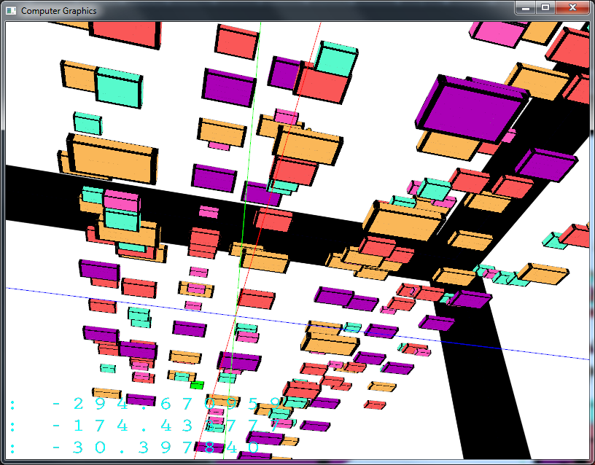

Driving Game

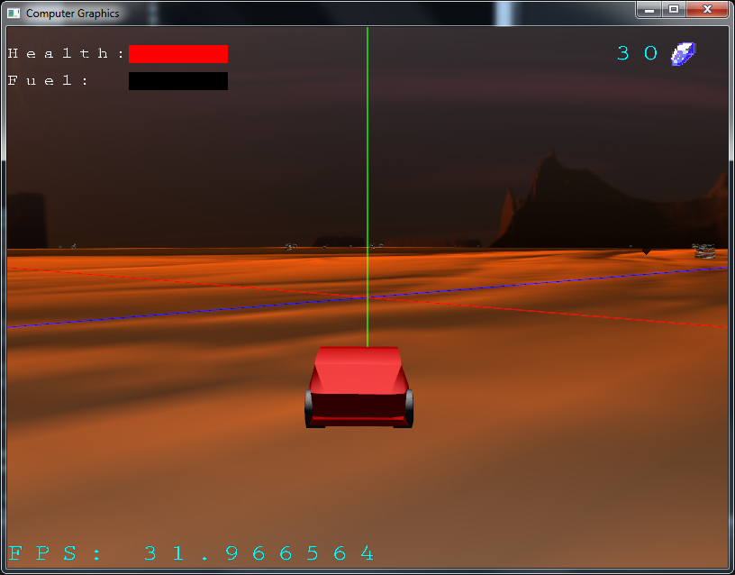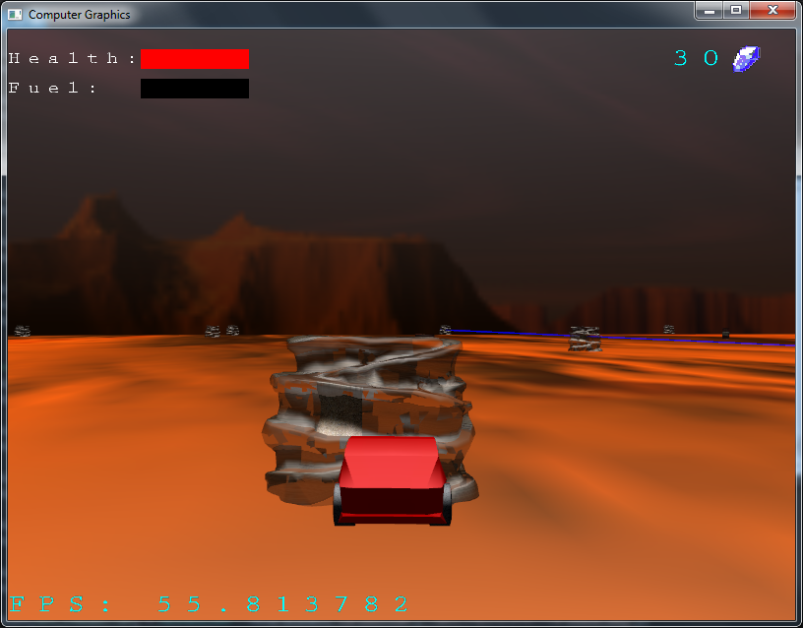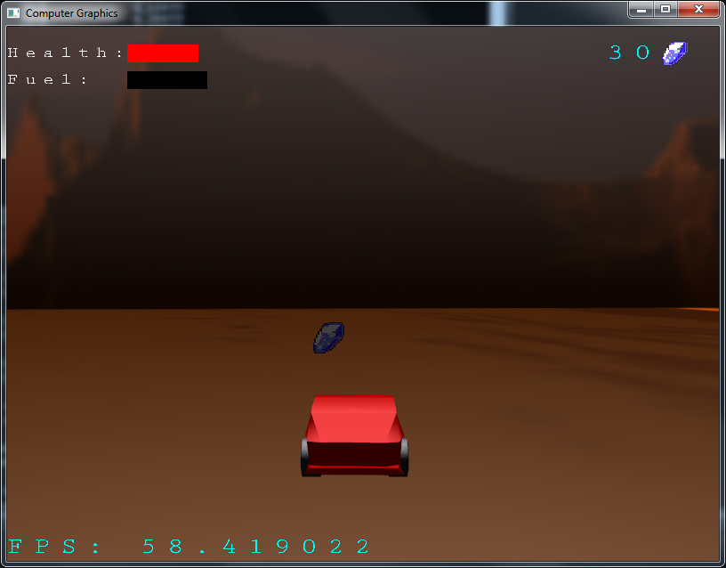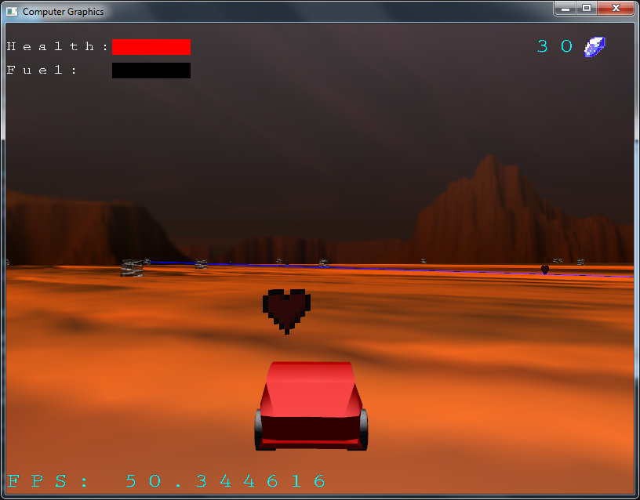

Shooting and treasure hunting Game

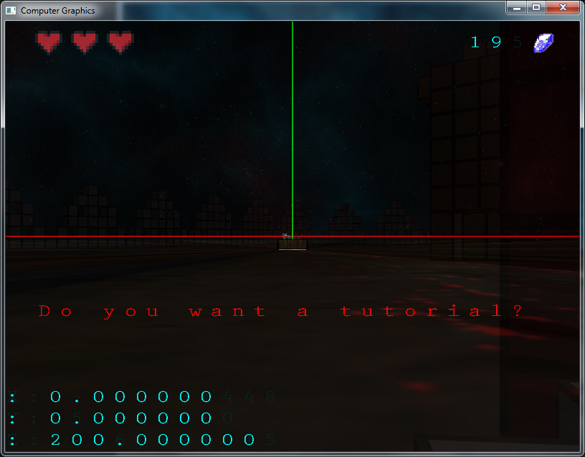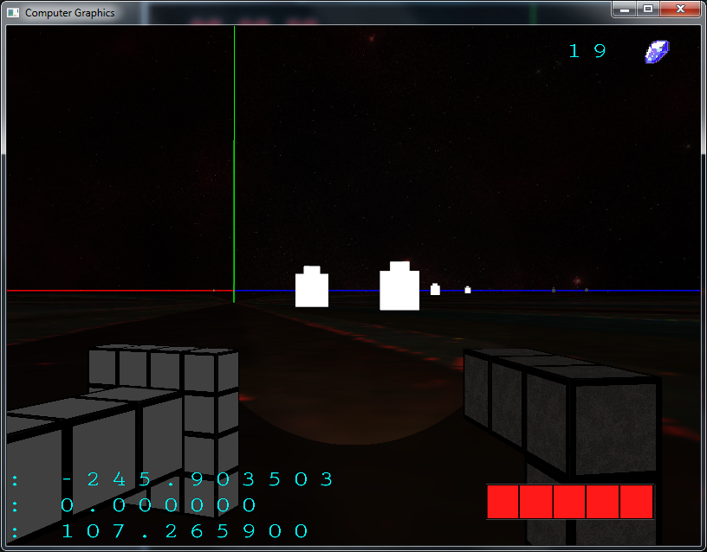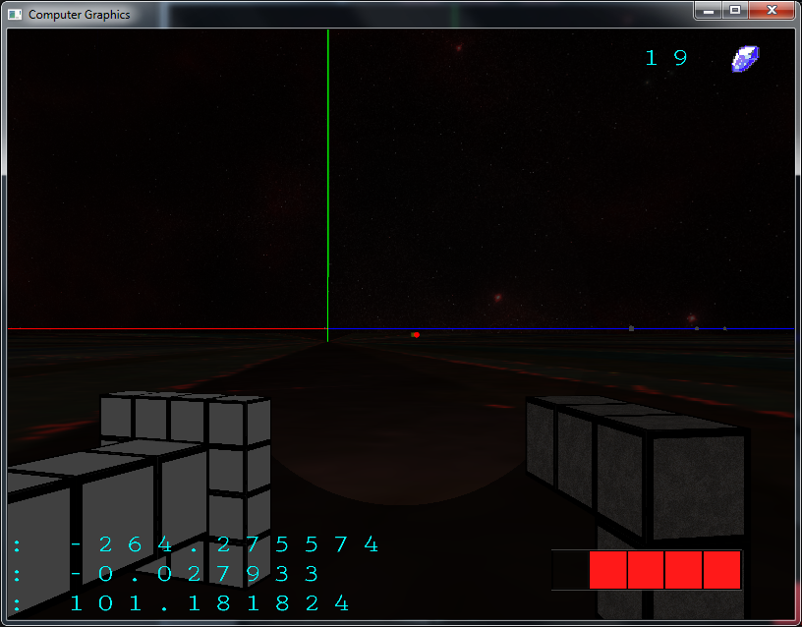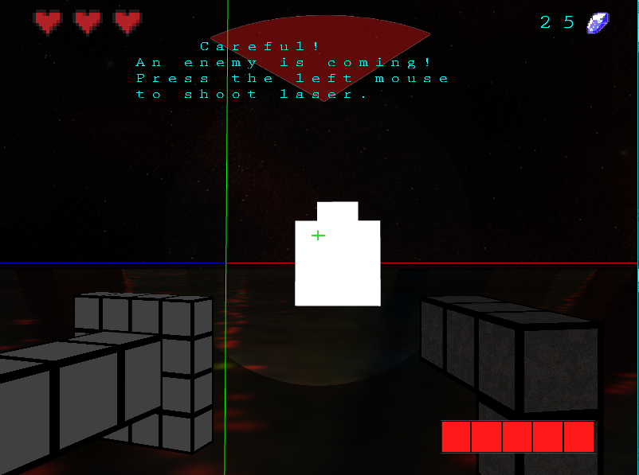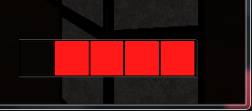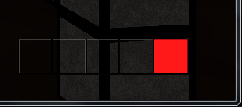

Spaceship Game

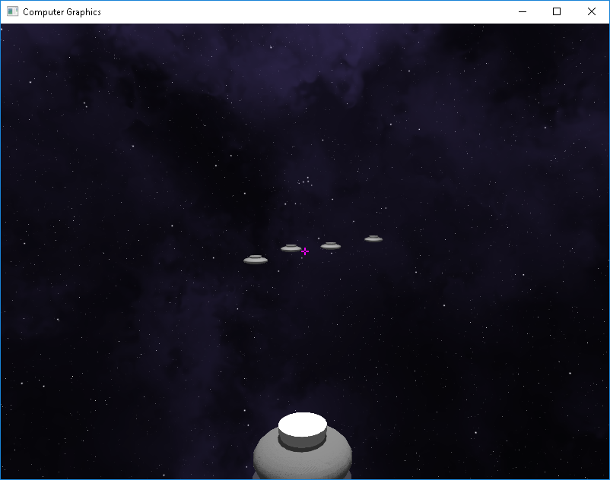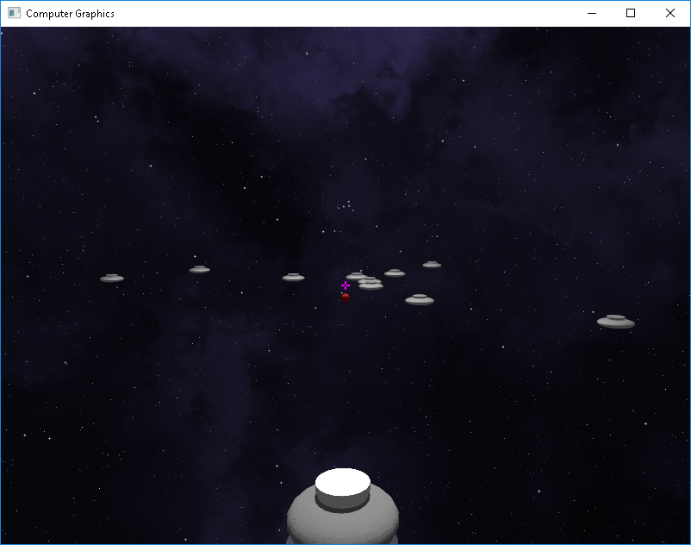

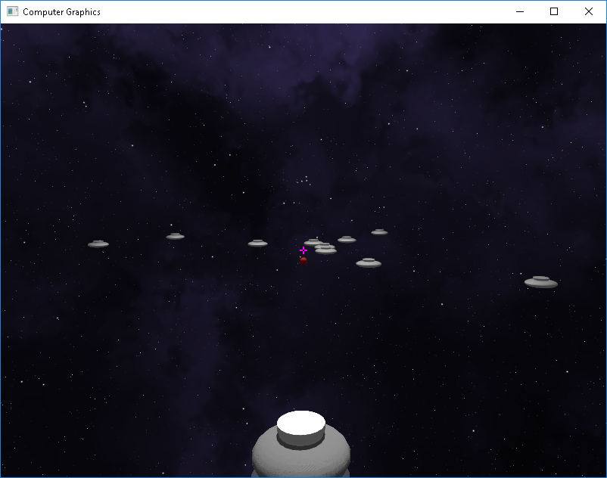(Bullet and crosshair)